DAILY TASK REMINDER
@CREATIVITY THINK (9483175986/7019689991)

ABSTRACT:
Daily Task Reminder is a web application designed to help users manage their daily tasks efficiently. Users can set reminders, schedule recurring tasks, and receive notifications, ensuring productivity and habit formation. Administrators can manage templates, configure notification settings, and monitor usage statistics through interactive dashboards. Developed using Django and Django Rest Framework for the backend, and React, Redux, and Recharts for the frontend, this system offers a secure, centralized platform for task management and analytics, improving organizational efficiency and user engagement..

INTRODUCTION OF THE PROJECT:
Managing daily tasks and recurring reminders is essential for productivity, habit development, and academic or professional performance. Daily Task Reminder provides a web-based platform where users can set reminders, schedule tasks, and track progress through dashboards. Administrators can manage templates, notifications, and analytics, enabling centralized oversight. Built with Django, DRF, React, Redux, and Recharts, the application ensures a robust and user-friendly interface, supporting both individual users and administrative monitoring for optimal task management..

PROJECT OBJECTIVES:

• Enable users to create and manage daily task reminders
• Support scheduling of recurring tasks
• Provide notifications for task completion or upcoming deadlines
• Allow administrators to manage templates and notification settings
• Track user engagement and dashboard statistics
• Reduce missed tasks and improve productivity
• Facilitate habit formation through consistent reminders
• Offer analytical insights for administrators

PROBLEM OF THE STATEMENT:
Many individuals struggle to remember daily tasks and manage recurring responsibilities effectively. Manual tracking can lead to missed deadlines, reduced productivity, and inefficient habit formation. Organizations or educators lack centralized platforms to monitor task adherence across users. This project addresses these challenges by providing a web-based task reminder system with recurring notifications, dashboard analytics, and administrative oversight, ensuring timely task completion and data-driven management..

MOTIVATION OF THE PROJECT:
• Improve productivity and task adherence for users
• Reduce missed deadlines and forgotten tasks
• Facilitate habit formation through recurring reminders
• Provide administrators with dashboards to monitor engagement
• Streamline management of templates and notification settings

BLOCK DAIGRAM OF PROJECT:

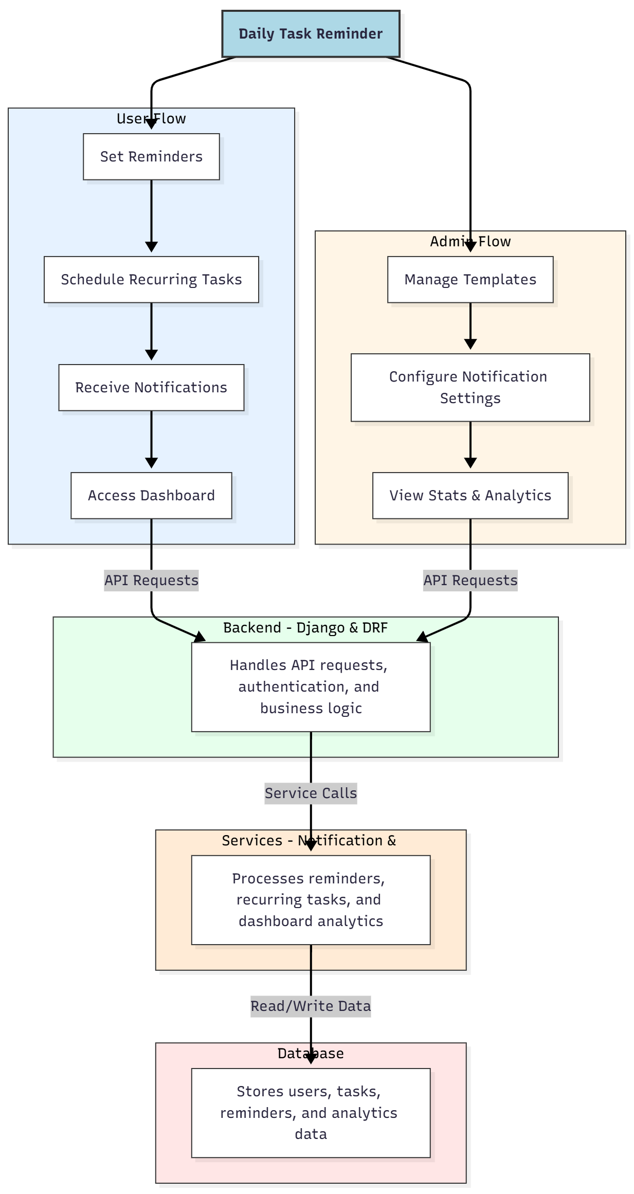

WORKING OF THE PROJECT:
Users log in to set individual reminders, schedule recurring tasks, and receive notifications for upcoming or overdue tasks. They can access a dashboard to view statistics on task completion and engagement. The backend handles authentication, API requests, and business logic, while services process notification scheduling and analytics calculations. Administrators manage templates, configure notification settings, and monitor dashboard statistics to ensure effective task management and improved productivity across users..

SOFTWARE REQUIREMENT:
- Backend:
  - Python 3.x
  - Django
  - Django REST Framework
  - SQLite/PostgreSQL
- Frontend:
  - Node.js and npm
  - React.js
  - Axios
- Development Tools:
  - Visual Studio Code
  - Postman (for testing APIs)
  - Git/GitHub (for version control)
- Server/Deployment (Optional):
  - Gunicorn, Nginx, or Heroku/AWS for hosting

ADVANTAGES OF THE PROJECT:

• Enhances productivity by reminding users of tasks
• Supports recurring tasks to develop habits
• Provides dashboards for progress tracking
• Centralized management for administrators
• Reduces missed deadlines and forgotten tasks
• Data-driven insights via analytics
• Flexible notification and reminder settings
• Scalable for individual or group usage

APPLICATIONS OF THE PROJECT:
• Personal productivity enhancement
• Academic task management for students
• Habit formation and tracking
• Office and team task coordination
• Reminder systems for events and deadlines
• Personal health or wellness tracking
• Educational institution task management
• Analytics-driven task insights for administrators

REFERENCES:

- Django REST Framework Documentation — Django Software Foundation. Django Documentation. Available: https://docs.djangoproject.com/
- Django REST Framework. DRF Documentation. Available: https://www.django-rest-framework.org/
- React. React Official Documentation. Available: https://reactjs.org/docs/getting-started.html
- Redux. Redux Documentation. Available: https://redux.js.org/introduction/getting-started
- PostgreSQL Global Development Group. PostgreSQL Documentation. Available: https://www.postgresql.org/docs/
- MySQL. MySQL Reference Manual. Available: https://dev.mysql.com/doc/
- Git. Git Documentation. Available: https://git-scm.com/doc
- Node.js. Node.js Documentation. Available: https://nodejs.org/en/docs/
- Axios. Axios Documentation. Available: https://axios-http.com/docs/intro
- Socket.io Documentation – https://socket.io/docs/

